**Experiment 5**

**Aim:**

To write an ARM Assembly Language to find the number of bytes in a set of 10 locations that match the value 0xAC

**Tool Used:**

Keil uVision4

**Theory:**

LDRB is used to copy just 1 Byte of data to the lower location of the memory. LDR load multiple register locations with starting address mentioned. CMP compares two operands and if zero sets the zero flag. The EQ condition checks the zero flag for set to let the process happen.

**Code:**

 AREA PROGRAM, CODE, READONLY

 ENTRY

MAIN

    MOV R0, #10

    LDR R1, =0x00001000

LOOP

    LDRB R2, [R1], #1

    CMP R2, #0xAC

    ADDEQ R3,R3,#1

    SUBS R0,R0,#1

    BNE LOOP

    END

**Memory content**

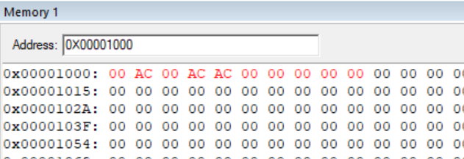

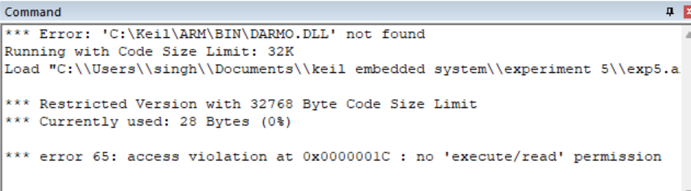

**Register Contents**

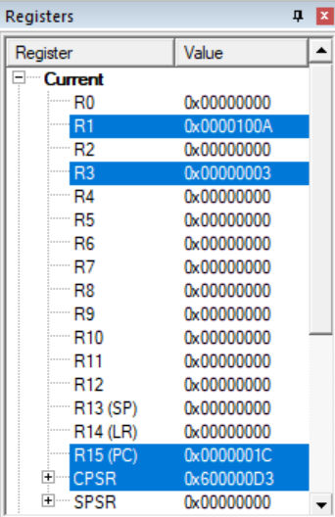

**Result:**

The experiments on compare operation have been performed and verified to be correct.